DEPARTMENT OF ELECTRICAL AND ELECTRONICS ENGINEERING
NEWS LETTER AUG 2019
EEE ZONE 1

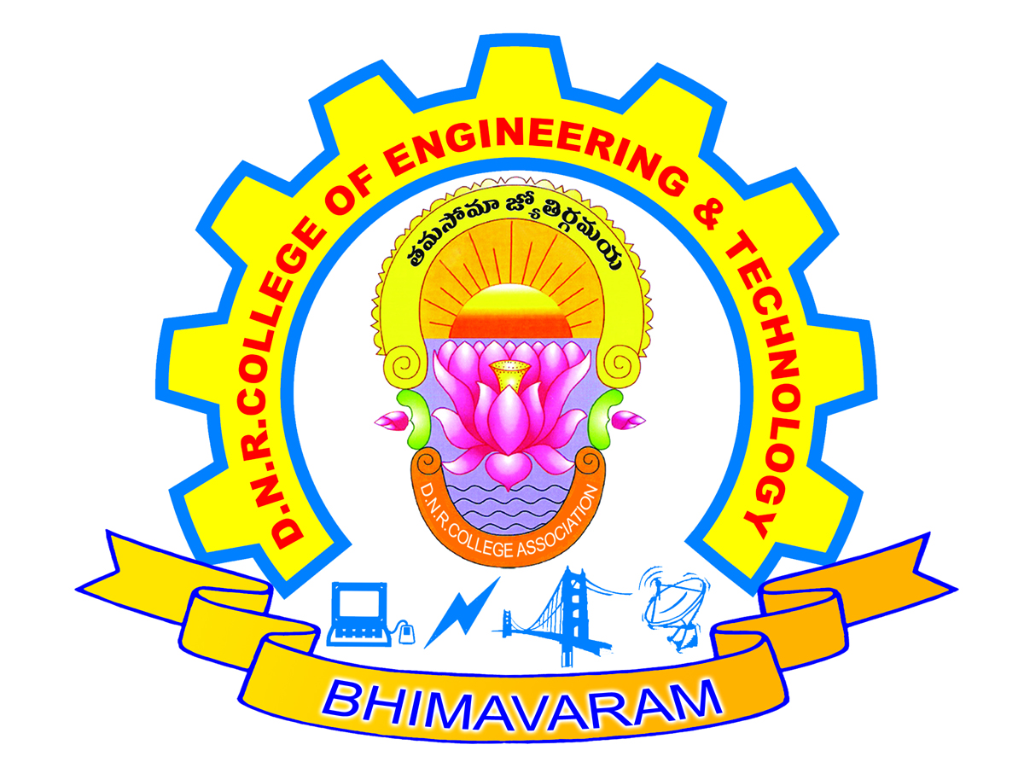

DNR COLLEGE OF ENGINEERING AND TECHNOLOGY

INSIDE THIS ISSUE
- About the department
- Department vision and mission
- Faculty in News
- Department Activities Student Achievements

About the Department:
The Department of Electrical Engineering was started in the year 2010 with an intake of
60. The department has state of the art equipment catering to the needs of both academia and industry. The Department has 10 faculty members and 3 technicians.
The Department produce well trained electrical graduates.

Department Vision and Mission: Vision

Empowering students with the contemporary knowledge in Electrical and Electronics Engineering for their success in life

Mission

To learn and practice latest technologies in Electrical and Electronics Engineering
Platforms Prevalent in industry.

Integrated with opportunities for team work, leadership, values, ethics and social activities.
Do the Earth a favor, be a power saver

EEE ZONE 2

Faculty in News:

Faculty Participations:
H Sri. S.Rajesh, Assistant Professor,is attended One Week National Level Faculty Development Program on “Research Methodology” From JULY 8th to 12th 2019 .Jointly Organised by Department Of Mechanical Engineering, S.R.K.R. Engineering College, Bhimavaram.
H Sri. G. Saibaba, Assistant Professor is attended One Week National Level Faculty Development Program on “Basics of AC and DC DRIVES” From JULY 1ST to 6th 2019.Organised by APSSDC in JNTUK,Kakinada

Department Activities:

Department of Electrical and Electronics Engineering organized a one day Seminar on “Advancements On Switchgear Protection” by Professor DR. Suresh Kumar,GRIET, HYD on 25thJAN 2019.

Department of Electrical and Electronics Engineering organized a one day Seminar on “Power Conversion Technologies & Applications” by G.Venkatesh SRIFABTECH, BANGALORE,on 13thFEB 2019.

Department of Electrical and Electronics Engineering organized a two days Workshop on “Advanced Technologies in PV & Smart Grid” by Professor G.Neelakantam,SRIFABTECH, BANGALORE ,on 11th and 12thMAR2019.

One day workshop organized by the Institution for teaching on “Applications of FACTS in Power Electronics” on 12th JULY 2019.

One day Industrial visit to 132/33kv EHT Substation-Bhimavaram for III and IV B.tech EEE students on 23 JULY 2019.

Plan to conduct“ENCORE 2K19” A National level technical symposium on DEC2019.

EEE ZONE 3

Student achievements:
H Kamisetti Prathima is selected in SV Tech Solutions-Chennai on 07thMAR 2019.
H Nukavalli Dhana Raju is selected in Digital India Tech Solutions- HYD 27thMAR 2019.
H Kagitha Ramesh is selected in Digital India Tech Solutions- HYD 27thMAR 2019.
H Mudunuri Bhargav Sai Kumar Raju is selected in Digital India Tech Solutions- HYD 27thMAR 2019.
H Punnam Prasanna Kumar is selected in Digital India Tech Solutions- HYD 27thMAR 2019.
H Katikithala Srikanth is selected in Radar Motors-HYD on 18thAPRIL 2019.
H Jogi Dasaradha Ram is selected in Radar Motors-HYD on 18thAPRIL 2019.
H Talagalla Suresh is selected in Radar Motors-HYD on 18thAPRIL 2019.
H Ponala Chanakya is selected in Radar Motors-HYD on 18thAPRIL 2019.
H Akkina Siva Rama Krishna is selected in Radar Motors-HYD on 18thAPRIL 2019.
H Neelam Sai Naga Durga Prasad Raju is selected in Radar Motors-HYD on 18thAPRIL 2019.
H Kusampudi Suresh Varma is selected in Radar Motors-HYD on 18thAPRIL 2019.
H Bollam Ramu is selected in Radar Motors-HYD on 18thAPRIL 2019.
H Kavuru Vamsikrishna is selected in Radar Motors-HYD on 18thAPRIL 2019
e Ea p Workshops

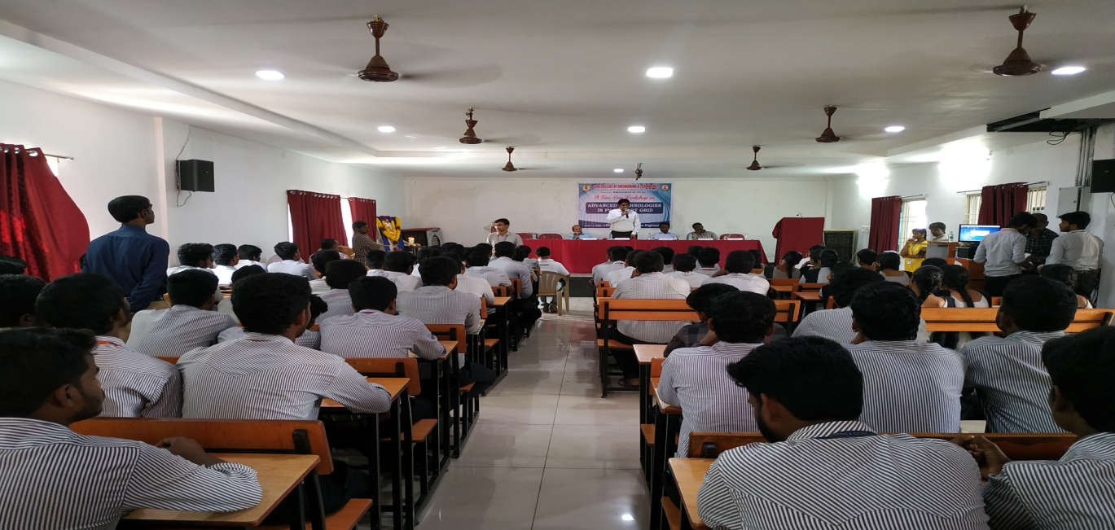 wer saver

A two days Workshop on “Advanced Technologies in PV & Smart Grid”

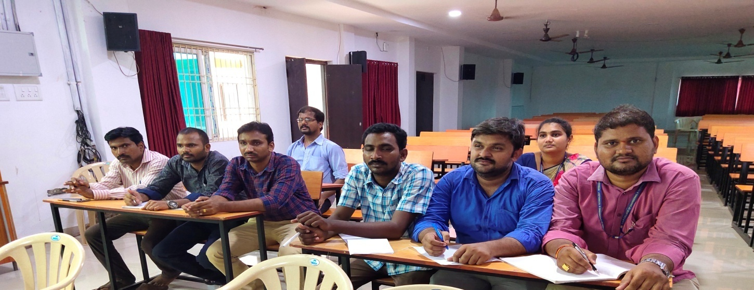

One day workshop organized by the Institution for teaching on “Applications of FACTS in Power Electronics”

Industrial visits

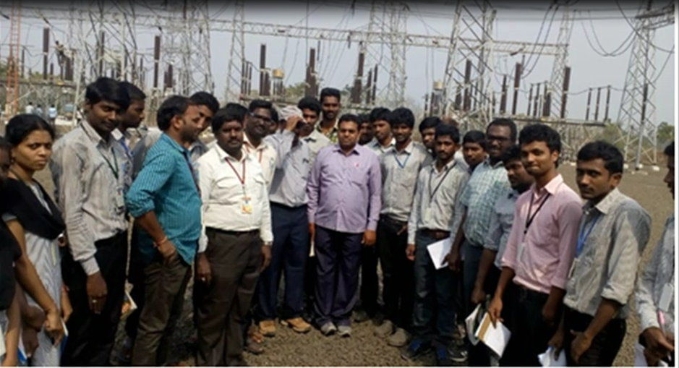

One day Industrial visit to 132/33kv EHT Substation-Bhimavaram

