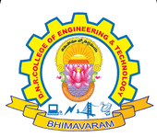
DNR COLLEGE OF ENGINEERING & TECHNOLOGY
Balusumudi, Bhimavaram-534 202, W.G.DT.
DEPARTMENT OF COMPUTER SCIENCE ENGINEERING
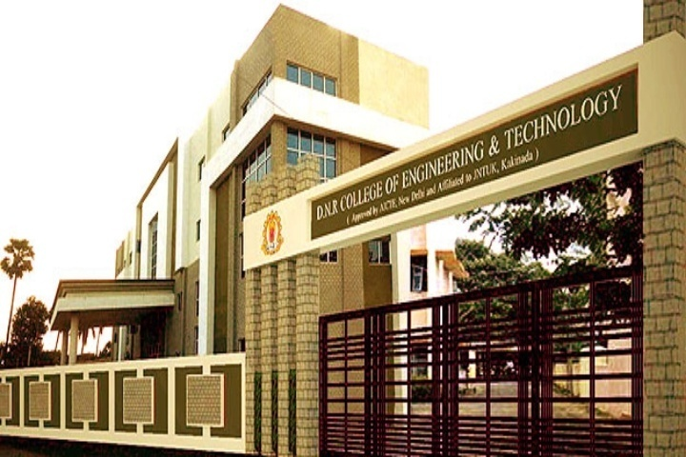
A ABOUT DEPARTMENT

The Department of Computer Science and Engineering at DNRCET was established in 2010. The department offers Undergraduate course B.Tech with 120 seats and also offers post graduation of M.Tech in Computer Science & Engineering with 18 seats.
The Department has highly qualified and experienced faculty with a minimum qualification of M.Tech. The Department of CSE has sophisticated computing facilities like splendid computer labs with latest and
Facilitate and equipped configuration systems. The Department has conducted various seminars and workshops to inculcate latest technologies to the students and to meet the industrial requirements.
The computer industry is one of the fastest growing segments of our economy and that growth promises to continue well into the next century. Thus, computer engineering is one of the fastest growing career fields in the world. Computer engineers work in almost every industry starting from health care and gaming to banking and online shopping. They might find themselves in a variety of environments in academia, research, industry, government, private and business organizations–analyzing problems for solutions, for mutating and testing, using advanced communications, or working in teams for software development.

VISION

- Establishing unique identity by development of high quality human and knowledge resources in the area of Computer Science and Engineering to meet Local, National and Global economic and social needs of the society in self-sustained manner.
MISSION

- To train and transform young learners into responsible thinking engineers, technologists and scientists in the area of Computer Science and Engineering.
- To motivate the students to attain professional excellence and inspire them to proactively engage themselves for the betterment of the society.
SSSSAsS SALIENT FEATURES

- State of the Art Computing Facilities
- ICT in Teaching and Learning
- Teacher as Mentor
- Research & Publications with Social Impact
- Supportive Learning for Placements
- Professional Development for Industrial Engagement
FACULTY STRENGTH

- The Department has well Experienced Ph.D. holders
- The Department has good number of well experienced and dedicated faculties with M.Tech. And some of them are pursuing Ph.D.

Workshop

- A workshop was conducted on
Python Programming and its
Applications from 21st July to
23rd July 2019 at auditorium of
our college.
YOGA DAY

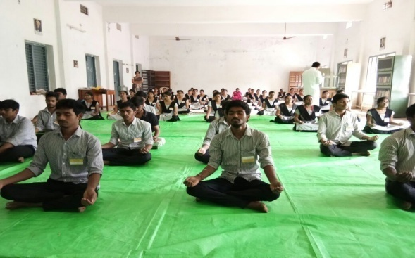

- YOGA day was organised by CSE department on 22nd June.

SPORTS DAY
.

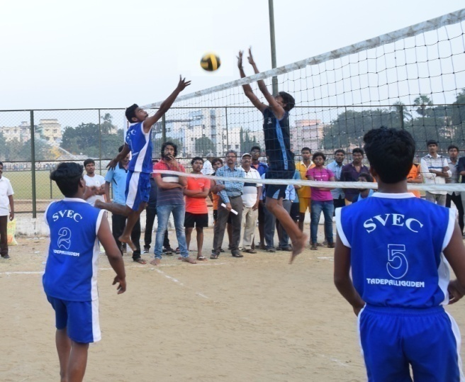
- Sports day was conducted on 29th august in the college campus.

NSS

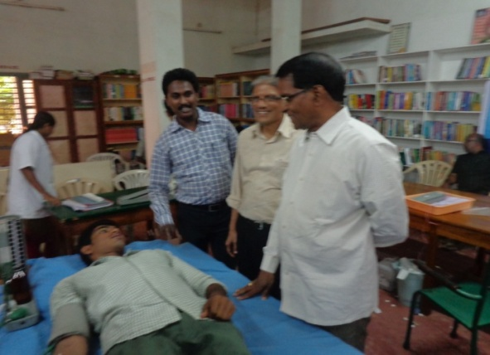

- NSS was organized in the College
by students.

ADD-ON COURSES ORGANIZED

