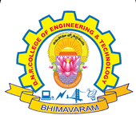
DNR COLLEGE OF ENGINEERING & TECHNOLOGY
Balusumudi, Bhimavaram-534 202, W.G.DT.
DEPARTMENT OF COMPUTER SCIENCE ENGINEERING
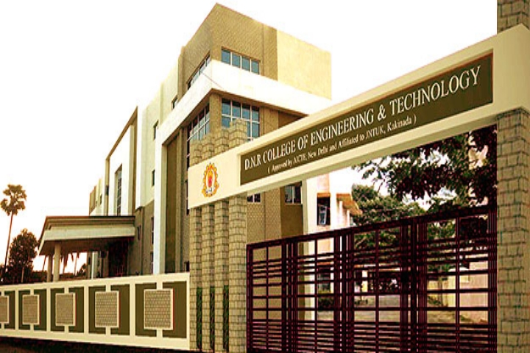
A ABOUT DEPARTMENT

The Department of Computer Science and Engineering at DNRCET was established in 2010. The department offers Undergraduate course B.Tech with 120 seats and also offers Postgraduate course M.Tech in Computer Science & Engineering with 18 seats.
The Department has highly qualified and experienced faculty with a minimum qualification of M.Tech. The Department of CSE has sophisticated computing facilities like splendid computer labs with latest configuration systems. The Department has conducted various seminars and workshops to inculcate latest technologies to the students and to meet the industrial requirements.
The computer industry is one of the fastest growing segments of our economy and that growth promises to continue well into the next century. Thus, computer engineering is one of the fastest growing career fields in the world. Computer engineers work in almost every industry starting from health care and gaming to banking and online shopping.They might find themselves in a variety of environments in academia, research, industry, government, private and business organizations–analyzing problems for solutions, for mutating and testing, using advanced communications, or working in teams for software development.

VISION

- Establishing unique identity by development of high quality human and knowledge resources in the area of Computer Science and Engineering to meet Local,National,and Global economic and social needs of the society in self-sustained manner.
MISSION

- To train and transform young learners into responsible thinking engineers,technologists and scientists in the area of Computer Science and Engineering.
- To motivate the students to attain professional excellence and inspire them to proactively engage themselves for the betterment of the society.
SALIENT FEATURES

- State of the Art Computing Facilities
- ICT in Teaching and Learning
- Teacher as Mentor
- Research & Publications with Social Impact
- Supportive Learning for Placements
- Professional Development for Industrial Engagement
FACULTY STRENGTH

- The Department has well Experienced Ph.D. holders
- The Department has good number of well experienced and dedicated faculties with M.Tech. And some of them are pursing Ph.D.
- Mr. B Nandan Kumar has received 46th AP STATE Badminton Teacher Tournament Winner.
FACULTY ACHIEVEMENTS

- Mr. B Nandan Kumar has received 46th AP STATE Badminton Teacher Tournament Winner.

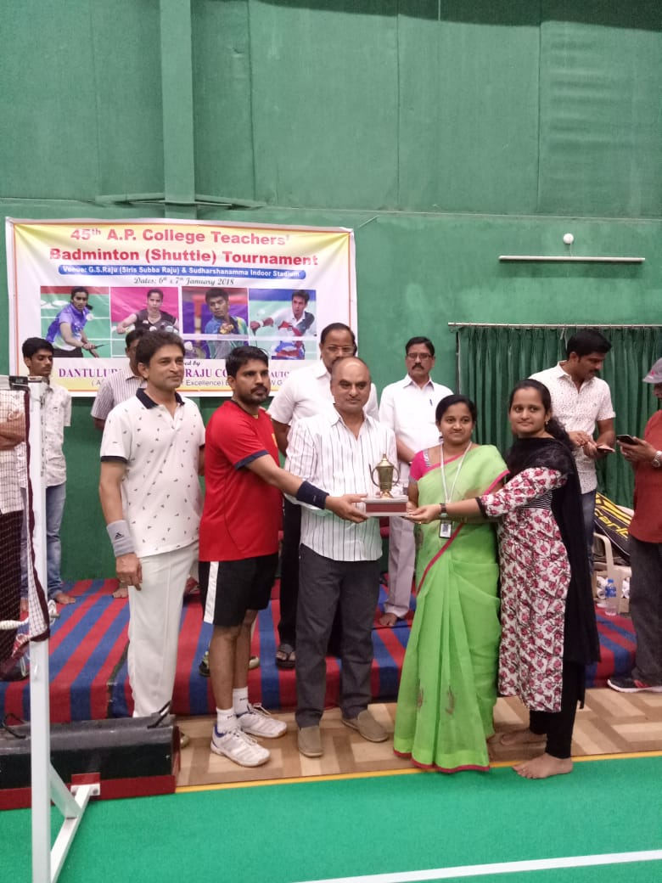
AVISHKAAR-2K18

ADD-ON COURSES ORGANIZED
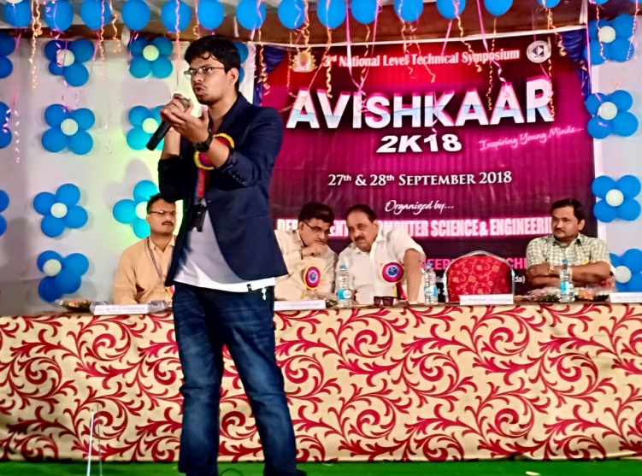
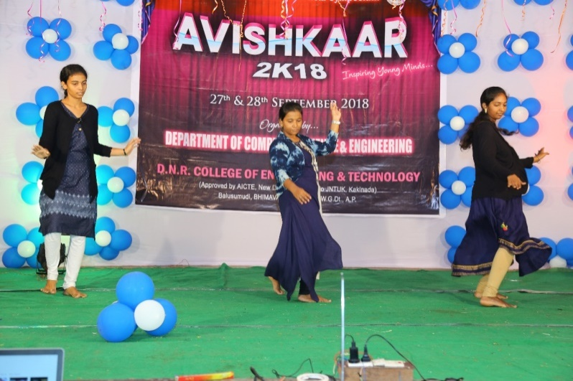

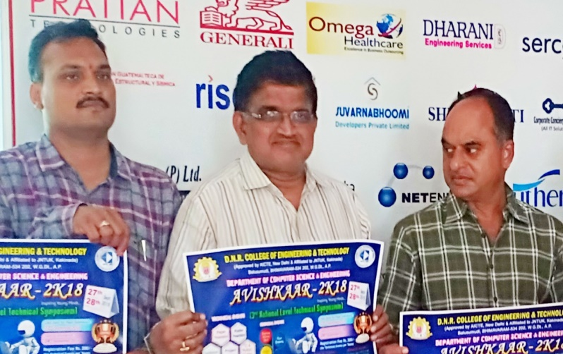
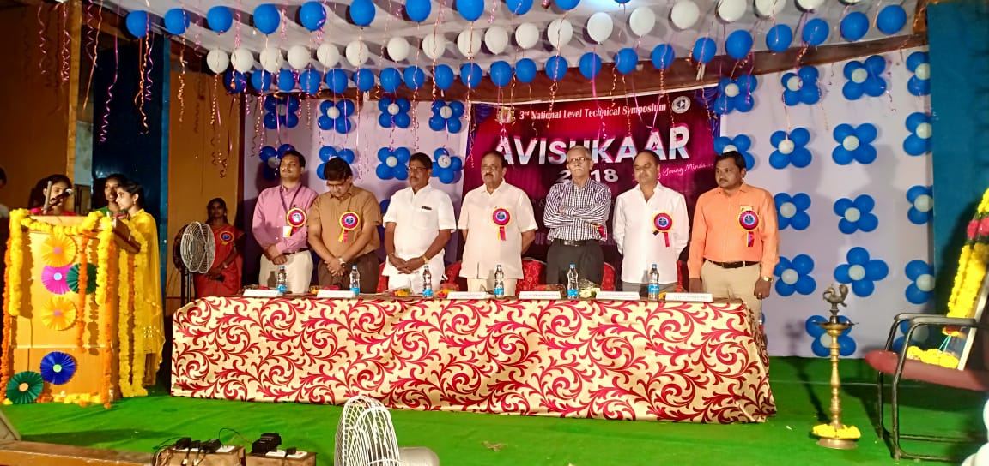

- Avishkaar-2k18 was organized by CSE department on 27th, 28th Sept. 2018.
- On this occasion Allena Pavan ( CEO of Meta Morphosis) delivered his valuable speeches to motivate the students.

WORKSHOP ON 3D ANIMATION

- Animation generally ivolved in generating animated images.
- The more general term computer-generated imagery(CGI) encompasses both static scenes dynamic images,while computer animation only refers to the moving images.
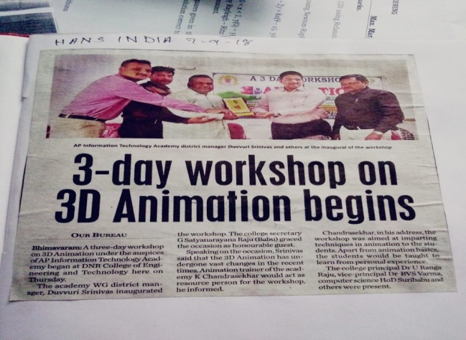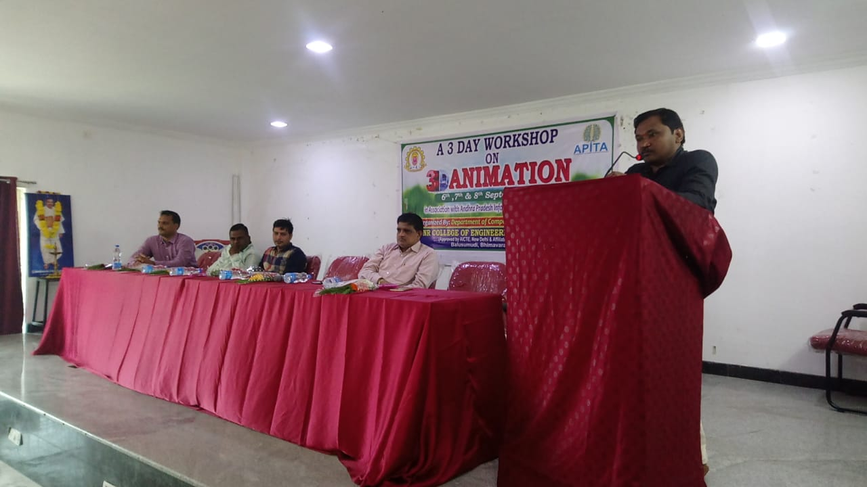
- 3D Animation workshop was organized by CSE department on 6th,7th,8th sept.2018.
- On this occasion the honourable guest K.Chandrasekhar delivered his valuable message to students that workshop was aimed at imparting techniques in animation to the students.
- Apart from animation basics,the students would be taught to learn from personal experience.
SEMINARS

DATA ANALYSIS USING WEKA
- WEKA, formally called Waikato Environment for Knowledge Learning, is a computer program that was developed at the University of Waikato in New Zealand for the purpose of identifying information from raw data gathered from different domains.
- WEKA supports many different standard data mining tasks such as data pre-processing, classification, clustering, regression, visualization and feature selection. The basic premise of the application is to utilize a computer application that can be trained to perform machine learning capabilities and derive useful information in the form of trends and patterns.
- This was conducted on 10 Aug 2018, Mr. Raavi SivaReddy, VLXIT solutions Vijayawada delivered his valuable message to students.

