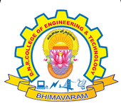
DNR COLLEGE OF ENGINEERING & TECHNOLOGY
Balusumudi, Bhimavaram-534 202, W.G.DT.
DEPARTMENT OF COMPUTER SCIENCE ENGINEERING
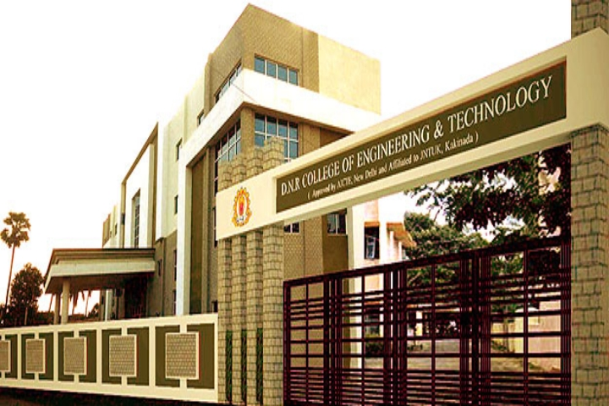
A ABOUT DEPARTMENT

The Department of Computer Science and Engineering at DNRCET was established in 2010. The department offers Undergraduate course B.Tech with 120 seats and also offers Postgraduate course M.Tech in Computer Science & Engineering with 18 seats.
The Department has highly qualified and experienced faculty with a minimum qualification of M.Tech. The Department of CSE has sophisticated computing facilities like splendid computer labs with latest configuration systems. The Department has conducted various seminars and workshops to inculcate latest technologies to the students and to meet the industrial requirements.
The computer industry is one of the fastest growing segments of our economy and that growth promises to continue well into the next century. Thus, computer engineering is one of the fastest growing career fields in the world. Computer engineers work in almost every industry starting from health care and gaming to banking and online shopping. They might find themselves in a variety of environments in academia, research, industry, government, private and business organizations–analyzing problems for solutions, for mutating and testing, using advanced communications, or working in teams for software development.

VISION

- Establishing unique identity by development of high quality human and knowledge resources in the area of Computer Science and Engineering to meet Local, National and Global economic and social needs of the society in self-sustained manner.
MISSION

- To train and transform young learners into responsible thinking engineers, technologists and scientists in the area of Computer Science and Engineering.
- To motivate the students to attain professional excellence and inspire them to proactively engage themselves for the betterment of the society.
SSSSAsS SALIENT FEATURES

- State of the Art Computing Facilities
- ICT in Teaching and Learning
- Teacher as Mentor
- Research & Publications with Social Impact
- Supportive Learning for Placements
- Professional Development for Industrial Engagement
FACULTY STRENGTH

- The Department has well Experienced Ph.D. holders
- The Department has good number of well experienced and dedicated faculties with M.Tech. And some of them are pursuing Ph.D.
Seminar

- A seminar was conducted on Databases with MySQL on 5th Feb in seminar hall of our college.
- A seminar was conducted on Networking and Security on 15th
Feb at college seminar hall.
ANNUAL DAY

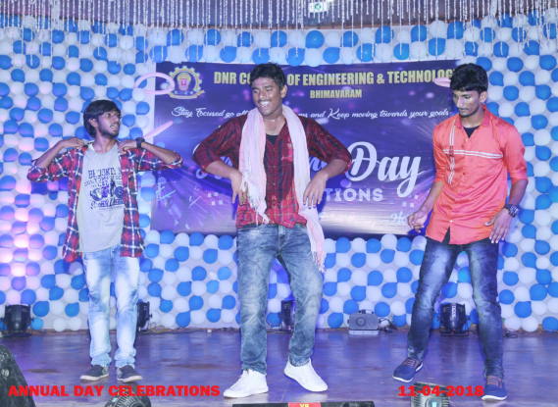
- Annual day was conducted on 10th march in auditorium.

CSE DAY

- Cse day was conduted on
March 10 at seminar hall.

NSS

AVISHKAAR

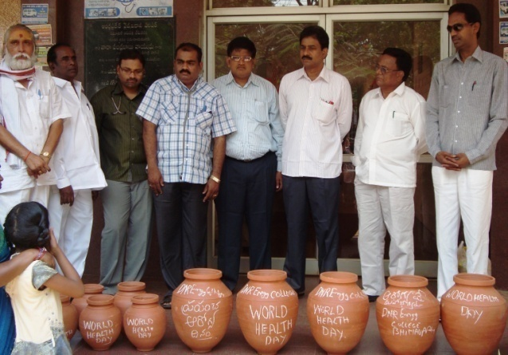
- NSS was organized in the
College.

