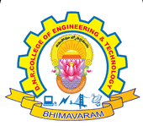
DNR COLLEGE OF ENGINEERING & TECHNOLOGY
Balusumudi, Bhimavaram-534 202, W.G.DT.
DEPARTMENT OF COMPUTER SCIENCE ENGINEERING
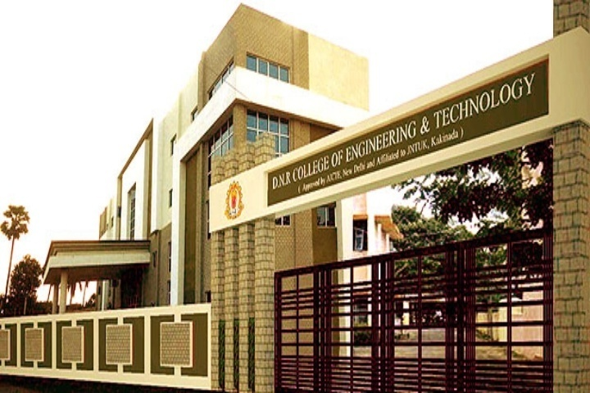
A ABOUT DEPARTMENT

The Department of Computer Science and Engineering at DNRCET was established in 2010. The department offers Undergraduate course B.Tech with 120 seats and also offers Postgraduate course M.Tech in Computer Science & Engineering with 18 seats.
The Department has highly qualified and experienced faculty with a minimum qualification of M.Tech. The Department of CSE has sophisticated computing facilities like splendid computer labs with latest configuration systems. The Department has conducted various seminars and workshops to inculcate latest technologies to the students and to meet the industrial requirements.
The computer industry is one of the fastest growing segments of our economy and that growth promises to continue well into the next century. Thus, computer engineering is one of the fastest growing career fields in the world. Computer engineers work in almost every industry starting from health care and gaming to banking and online shopping. They might find themselves in a variety of environments in academia, research, industry, government, private and business organizations–analyzing problems for solutions, for mutating and testing, using advanced communications, or working in teams for software development.

VISION

- Establishing unique identity by development of high quality human and knowledge resources in the area of Computer Science and Engineering to meet Local, National and Global economic and social needs of the society in self-sustained manner.
MISSION

- To train and transform young learners into responsible thinking engineers, technologists and scientists in the area of Computer Science and Engineering.
- To motivate the students to attain professional excellence and inspire them to proactively engage themselves for the betterment of the society.
SSSSAsS SALIENT FEATURES

- State of the Art Computing Facilities
- ICT in Teaching and Learning
- Teacher as Mentor
- Research & Publications with Social Impact
- Supportive Learning for Placements
- Professional Development for Industrial Engagement
FACULTY STRENGTH

- The Department has well Experienced Ph.D. holders
- The Department has good number of well experienced and dedicated faculties with M.Tech. And some of them are pursuing Ph.D.

WORKSHOP

- A workshop was conducted on
Internet of Things on 20th and
21st at the auditorium in our college.

SEMINAR

- A workshop was conducted on
Web Technologies on 27th Dec
at seminar hall of our college.

SANKRANTHI SAMBARALU

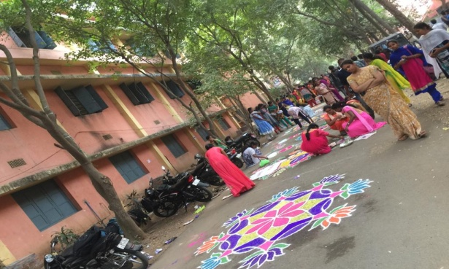
- Sankranthi sambaralu was organized
in the college on 11th and 12th of January Month and rangoli competitions were conduced.

YOUTH DAY
NSS

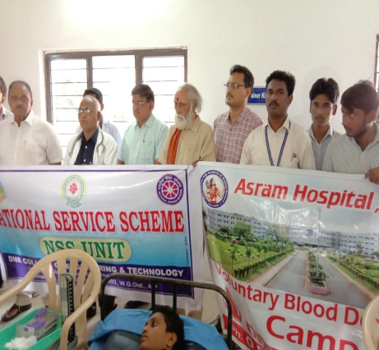
- NSS day was conducted in the college.

ADD-ON COURSES ORGANIZED

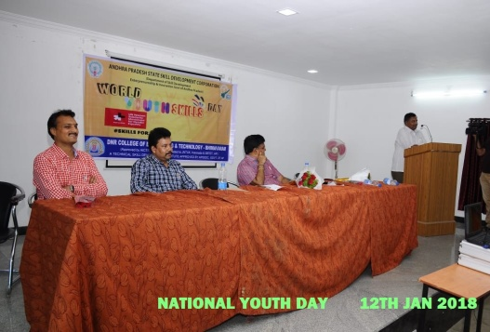
- Youth day was conducted on the 12th January
at the college seminar hall.

