**DNRCET–News Letter JUNE-SEPTEMBER 2019**

**DEPARTMENT OF MECHANICAL ENGINEERING**

**ABOUT COLLEGE**

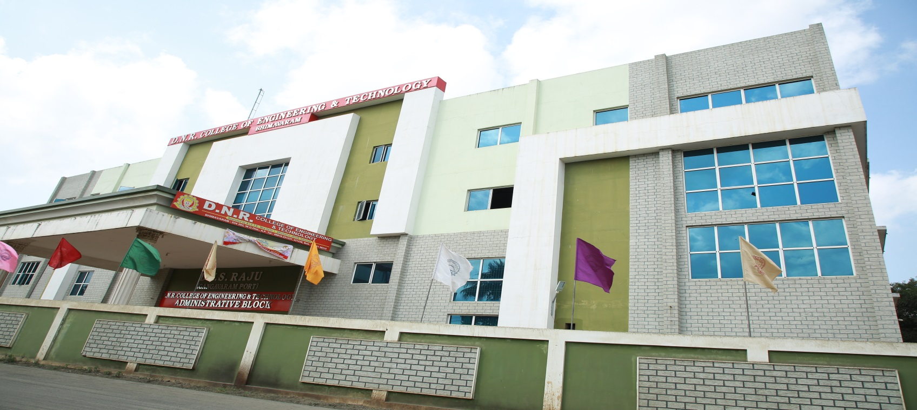

DantuluriNarayanaRaju College (D.N.R) was established in 1945, before India got Independence, and was an offshoot of the National movement and renaissance thinking. Being agrarian, the Godavari region had beenkept out of the higher education in the Pre-Independence period.**SriDantuluriNarayanaRaju**, a freedom fighter, an activist and a visionary wanted to provide the uneducated rural masses with the hither to unthinkable and unreachable source for their overall development and welfare i.e... higher education. That visionary, with the help of a limited number of committed lieutenants and Philanthropists, strived hard with a missionary zeal and realized the establishment of a college at Bhimavaram, Known as **West Godavari Bhimavaram (W.G.B) College** in 1945. In 1964 it was renamed as **DantuluriNarayanaRaju (D.N.R) College** in memory of its founder. Under this premier association DNR College of Engineering & Technology was established in the year 2010

**ABOUT DEPARTMENT**

The Department of Mechanical Engineering was started in the year 2010, which offers a 4 – year Under Graduate Programme (B.Tech). In 2011 we enhanced to 120 seats. In 2014 started with a Postgraduate course in Machine Design.The department consists of various laboratories and facilities with modern sophisticated equipment. The faculty and the students of the department are dedicated to work in the current needs of the industry and have the ability to improve expertise in fields of Mechanical Engineering

**VISION:** To evolve as Centre of Excellence in Teaching, Innovative Research, Entrepreneurship and Consultation in Engineering & Technology and to empower the rural youth with technical knowledge and professional competence thereby transposing them as globally competitive and self-disciplined technocrats.

**MISSION:** To inculcate technical knowledge and soft skills among rural students through student-centric learning process and make them as competent Engineers with professional ethics to face the global challenges, thus bridging the rural-urban divide.Strengthen industry institute interaction to enable the students to work on realistic problems and acquire the aptness to face the ever changing requirements.

**VISION&MISSION**

* One day national level seminar was conduced on “Natural Fibres& Synthetic Fibres” for III & IV year mechanical engineering students.
* A faculty development program on “Computational fluid dynamics and its applications” on 06/08/2019
* One week training program was conducted on PLC from 26/08/2019 to 31/08/2019 for IV year mechanical engineering students

**WORKSHOPS/SEMINARS/ TRAINING PROGRAMS**

**FACULTY FOCUS**

* A paper was published in International Journal Management on “Power Generation Using Two Silencer” by M.P.RangaRao, assistant professor in department of mechanical engineering.
* A paper was published in international journal of profession on “Detecting the landmines by defense robot” by DrD.BhanuPrakash, head of the mechanical engineering department inour college.

**CURRICULAR/CO-CURRICULAR EVENTS**

* Women’s day was celebrated on 8th march 2019.
* Yoga day was celebrated on 22nd June 2019

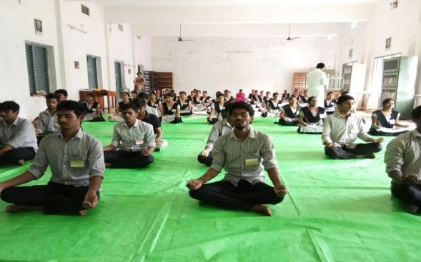

* Academic calendar for 2019-2020 was released on 30/05/2019
* The commencement of class work will be start on 10/0/2019
* 1st mid exams will be started from 05/8/2019 to 10/8/2019
* I year II semester results was released on may 2018 for 2017-2021 batch
* II year II semester results was released on April 2018 for 2016-2020 batch
* III year II semester results was released on April 2018 for 2015-2019 batch
* Teacher’s day was celebrated on 05th September 2019
* Sports day was celebrated on 29/08/2019

